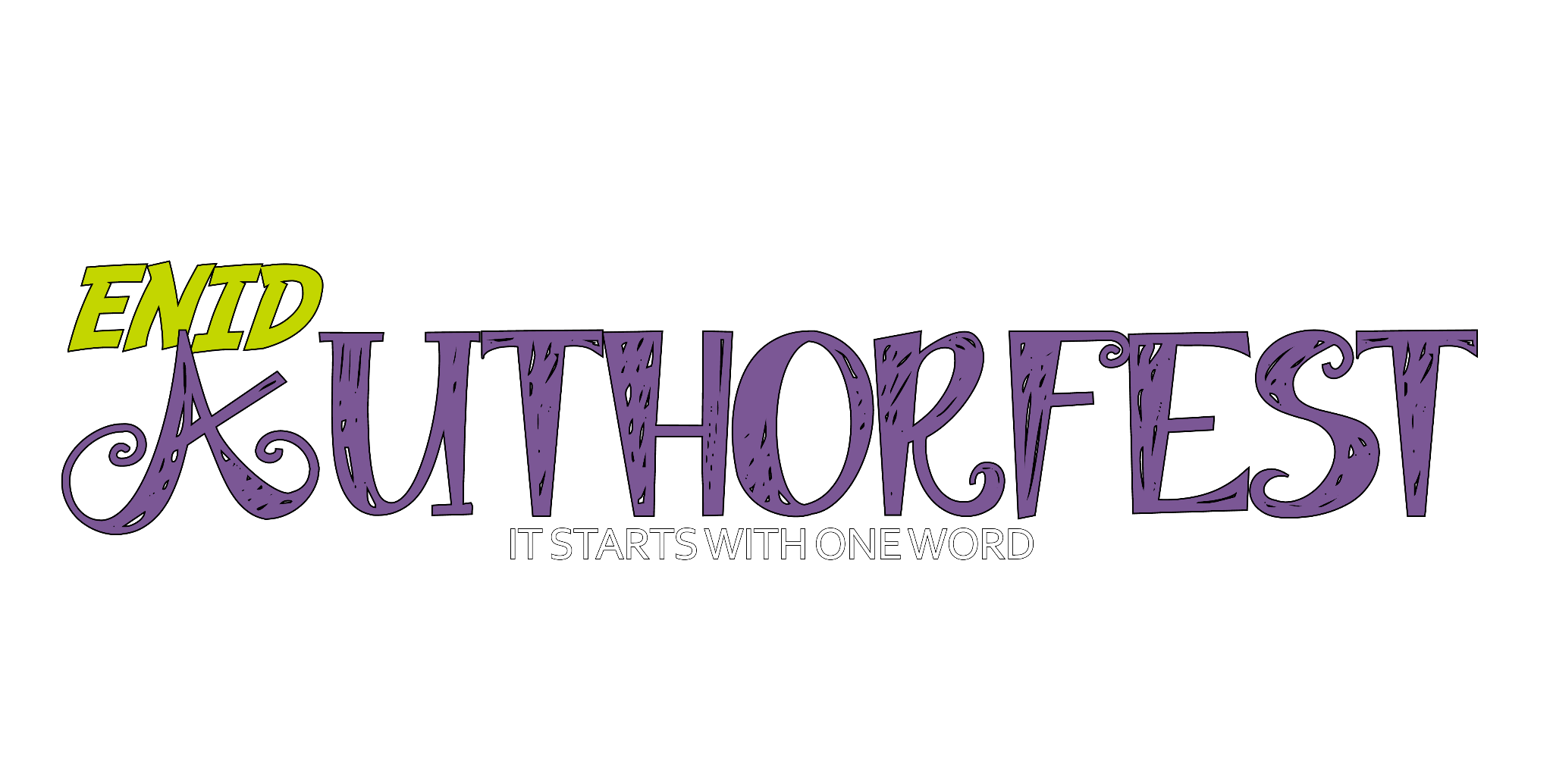
Dear Authors,
We are excited to extend an invitation for you to apply for participation in the 2024 Enid Author Fest. This is a wonderful opportunity for local authors to showcase their work and connect with the community.
The Enid Author Fest will be held at the Enid Public Library on Saturday, April 20, 2024 from 1:00-4:00 pm. This festival provides a platform for authors like yourself to present your work, engage with readers, and sell autographed copies of your books.
Here are some key details about the festival:
· Date and Time: Saturday, April 20, 2024 from 1:00-4:00 pm
· Location: Enid Public Library, 120 W Maine, Enid, OK 73701
Highlights of the Event:
1. Book Signing and Selling: Tables will be set up in the first-floor lobby for authors to sign and sell their books from 1:00-4:00 p.m.
2. Readings: Informal readings for children's and young adult authors will take place on the east side of the first floor, while readings for adults will be on the west side.
3. Sales and Tax: Authors are responsible for selling their books and collecting/submitting Oklahoma/Garfield County/City of Enid sales tax for the event. If you wish to bring your books to the festival and have our local bookstore, Putnam Six, take care of your sales, you are responsible for contacting Chloe Fuksa at chloef@putnamsix.com.
4. Table and Seating: The Enid Public Library will provide one-half of a six-foot table and a chair for each registered author. Due to space restrictions, extra chairs may be unable to be used.
5. Additional Events: This year, we are introducing new events to boost attendance, including door prizes, raffle tickets with each book sale for a grand prize, a children's coloring table, a storybook costume contest, and a book spine poetry contest.
6. Parking: Please be mindful of limited parking. Unload close to the library and then move your vehicle to the parking lot one block south and west of the library across the street from the Enid Event Center. Authors with handicap placards may park in the library alley.
7. Check-in: Check-in will begin at 11:00 am. We kindly request that participating authors stay for the entire event.

All participating authors are asked to submit $20 to the Enid Public Library. These funds will be used for advertising the event. Checks should be made out to the Enid Public Library with Enid Author Fest in the notes field. You may donate a book or merchandise for a door prize or raffle if you wish.
Please use the online registration to apply for participation: 2024 Enid Author Fest Registration.
For any questions or concerns, please contact mholmes@enid.org.
We look forward to your participation and the opportunity to celebrate local literary talent at the Enid Author Fest.
Warm regards,

Margo Holmes
Adult Programs and Development Coordinator
Enid Public Library
120 W. Maine, Enid, OK 73703
mholmes@enid.org

